1: Introducing Spatial

Maps are incredibly useful things. We use maps to understand reality, to decide on where to navigate, make sense of where we are - without maps, we are, quite often, lost. Maps are tools we have come to rely on to survive and thrive.

What is a map? [Wikipedia puts it concisely:](https://en.wikipedia.org/wiki/Map) "A map is a *symbolic depiction* emphasizing *relationships* between *elements* of some *space*." This definition captures the breadth of things we describe as "maps": from the traditional - paper [LandRanger maps](https://www.ordnancesurvey.co.uk/shop/maps.html) hikers use to explore the Scottish Highlands - to the more conceptual - a mind map of ideas around a topic, or a site map of pages of a website, or a map representing a network of firms competing in a market. In every case, accurate maps can help us understand a space in a more complete way than we can by simply observing it directly. Mapmakers do this by designing abstract representations of the space and the features within it.

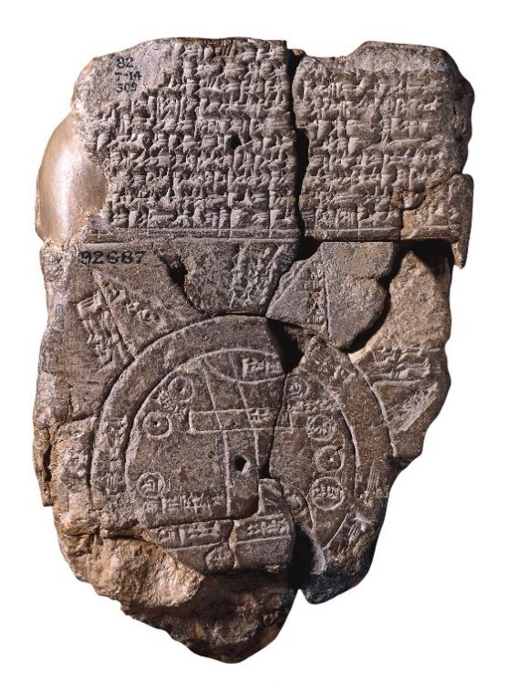 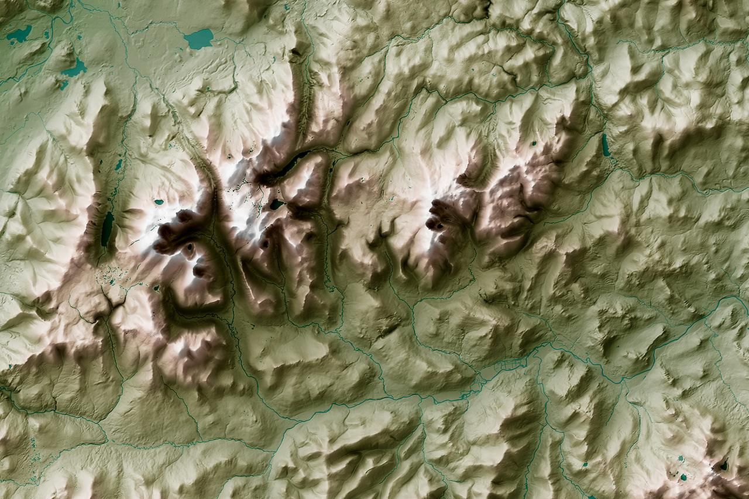

*The Babylonian****Imago Mundi****, the*[*oldest known map of the world*](https://en.wikipedia.org/wiki/Early_world_maps)*, alongside a shaded relief map created using the*[*OS Terrain 5 digital elevation model*](https://www.ordnancesurvey.co.uk/business-government/products/terrain-5)*.*